
https://conferences.ums.ac.id/icollit/

The Title in English, Times New Roman 14, Bold, 14 Words Maximum

Writer 1¹⁾, Writer 2²⁾ etc.
[Times New Roman 12, Bold, Italic, and No Abbreviations for Names]
¹Faculty, University/Institution (writer 1)
email: writer _1@abc.ac.id
phone:

²Faculty, University/Institution (writer 2)
email: writer _2@def.ac.id

DOI: 10.23917/icollit.vxxx.xxxxx
Received: July 1st, 2025. Revised: August 25th, 2025. Accepted: February 15th, 2026
Available Online: March 20th, 2026.
How to Cite:

Abstract
Abstract is written in English which briefly describes the main issues, objectives, method and findings of research in a single paragraph no more than 250 words. (Times New Roman 11, single space, italic, and justified).
Keywords: 5 keywords maximum separated by a comma from one keyword to the next. (Times New Roman 11, single space, and non-italic)

Abstrak

Abstrak ditulis dalam Bahasa Indonesia yang secara singkat menggambarkan isu utama, tujuan, metode, dan temuan penelitian dalam satu paragraf tidak lebih dari 250 kata. (Times New Roman 11, spasi tunggal, miring, dan rata kanan-kiri).
Kata kunci: maksimal 5 kata kunci yang dipisahkan dengan koma dari satu kata kunci ke kata kunci berikutnya. (Times New Roman 11, spasi tunggal, dan miring)

Introduction
The introduction contains the purpose of article/research that is formulated and presented by an adequate background. The introduction must cover the research urgency, supporting facts from previous studies, gap analysis, research status, research novelty, and research objective. The gap analysis means the gap found within the prior research, while the research status is the position towards previous studies whether it corrects, debates, or supports. The references must be taken from various Scopus indexed-journals published not later than 10 years from the article submission.

Method
In this part, research design, research scope or objectives, research tools and primary data, research setting, technique of data collection, operational research, and technique of data analysis are presented. Procedure and data analysis techniques should be emphasized to literature review article. The research stages should be clearly stated.

Result and Discussion
The results and discussion should be presented in the same part, clearly and briefly. The discussion part should contain the benefit of research result, not repeat result part. The research results could be supplemented with tables, figures, or graphs (separate writing terms) to clarify the discussion. Avoid presenting similar data in a separate table. The analysis should answer the gap stated. The qualitative data, e.g. interview results, is discussed in paragraphs. The references contained in the introduction should not be re-written in the discussion. A comparison to the previous studies should be presented.

Table 1. Title
No | Title | Title
1 | Content | Content
2 | Content | Content
3 | Content | Content
4 | Content | Content

The Example of Figure

Figure 1. Title

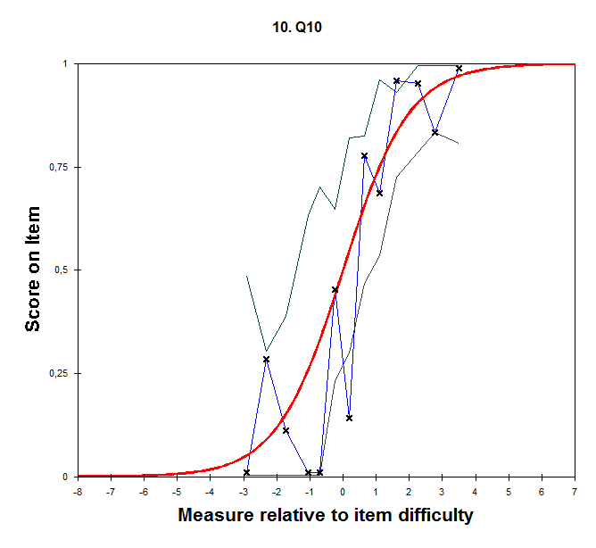
Figure 2. Title

Conclusion
The research conclusion is presented briefly, narrative and conceptual which describes the research findings and its impacts. The conclusion comprises the summary of research findings and discussion. Recommendations may also be inserted in this chapter. Please avoid using bullets. (Times New Roman 12, space 1.5)

Reference
In the manuscript referencing process, it is recommended to use citation manager applications such as Mendeley, Zotero, RefWorks, or EndNote. (Times New Roman 12, 1.5 spacing). The referencing style must follow the American Psychological Association (APA) format. Unpublished references are not recommended to be cited in the article. This journal requires that 80% of the references cited come from national and international journals (see author guidelines on the journal website for complete guidance).

Example reference
Books
Anderson, B. (1983). Imagined communities: Reflections on the Origins and Spread of Nationalism. Amsterdam: Verso.

E-books:
Bass, L., Clements, P., & Kazman, R. (2003). Software Architecture in Practice (2nd ed.). Addison Wesley. Available from Safari E-book.

Article in Online Encyclopedia:
Ince, D. (2001). Acoustic Coupler. In A Dictionary of the Internet. Oxford University Press. Retrieved from http://www.oxfordreference.com

Journal Article Abstract (accessed from online database):
Kimour, M. T., & Meslati, D. (2005). “Deriving Objects from Use Cases in Real-time Embedded Systems”. Information and Software Technology, 47(8), 533. Abstract retrieved from ProQuest: http://www.umi.com/proquest/.

Journal Article in Scholarly Journal (published free of charge on the Internet):
Altun, A. (2005, July). “Understanding Hypertext in the Context of Reading on the Web: Language Learners’ Experience”. Current Issues in Education, 6(12). Retrieved from http://cie.ed.asu.edu/volume6/number12/.

Newspaper Article from the Internet:
Wilson-Clark, C. (2007, March 29). “Computers Ranked as Key Literacy”. The Atlanta Journal-Constitution. Retrieved from http://www.thewest.com.au/.

